How to limit the computer in the lan to access the Internet through Client Filter

Product line: wireless Question category: function configuration

Q：Why we should configure Client Filter?

A：To benefit your further management to the computers in the LAN, you can control some PCs with certain IP address access to Internet by setting Client filter to achieve it.

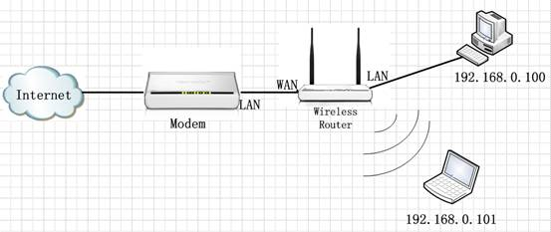

The steps are followings:

1．Please login to the management page of the router.
2．Click Parental Control--Client Filter and you will find the page as below. There are three options (Disable, Forbid only, and Permit only). The Client Filter is Disable default.

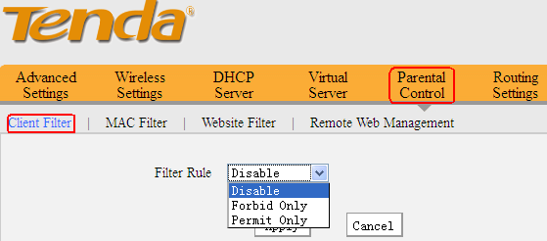

For example, we want to limit the computer with IP address during 192.168.0.100~192.168.0.200 to access the internet from 8:00 to 18:00 from Monday to Friday. And the computer with other IP Address can access internet. You can set the router following the picture as below.

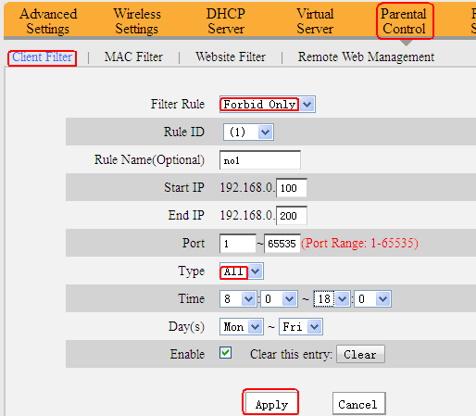

For example, we only want the computer with IP address (192.168.0.100~192.168.0.200) to access the internet and others can’t access Internet. You can set the router following the picture as below.

